*ecse 211 design project*

Hardware Document

Version *1.02*

*03/12/2018*

*ECSE 211 TEAM 11*

VERSION HISTORY

|  |  |  |  |  |
| --- | --- | --- | --- | --- |
| **Title** | Hardware Document | | | |
| **Description** | Keeps track of all Hardware related design and building | | | |
| **Created By** | Enan Ashaduzzaman, Hardware Team Leader | | | |
| **Date Created** | 2st March 2018 | | | |
| **Version Number** | **Modified By** | **Modifications Made** | **Date Modified** | **Status** |
| 1.00 | Enan Ashaduzzaman | Created the Document. Asserted 3 possible preliminary designs coupled with their respective advantages/disadvantages | 2nd March |  |
| 1.01 | Luka Jurisic | Peer reviewed the document. Formatted the Document | 3rd March | Preliminary Week 2 submission Content complete |
| 1.02 | Luka Jurisic, Enan Zaman | Enan-Added section 4- Comparison of designs.  Luka- Removed possible design #2 as it was completely unfeasible. Formatted Enan’s Work | 12th March | Wheel design chosen. Building must follow |

TABLE OF CONTENTS

# 1 Table of Contents

# 2 Design Process

# 3 PrelimAnary Designs

3.1 Prelimanary Design #1

3.2 Prelimanary Design #2

# 4 Comparision of Designs

# 2 DESIGN PROCESS

In the preliminary stages of the project, multiple designs were created while taking into account the Systems, Constraints, and Requirements documents. These designs and ideas mainly came from the research and development phase of the project. From previous experiences of the past five labs, all three teams put their knowledges together in order to think of the best suitable designs for the robot.

At the end of the week, the team came to a consensus that three designs were best suited for the project. The advantages and disadvantages of each designs were looked at and through testing, the team will have a better knowledge of which design to work with during the final phase of the project.

# 3 PrelimAnary Designs

**3.1 Prelimanary Design #1**

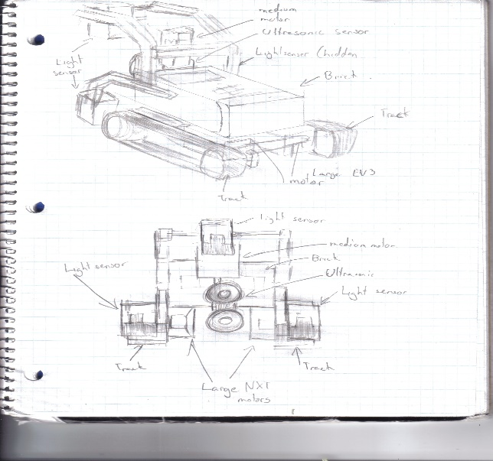

The design consists of three main features. The robot will be utilizing the track belt rather than the traditional wheels. The wheels will be attached to two large EV3 motors as they are better structured than the previous generation. With the better traction of the belt, it is believed that the robot will have more grip, thus helping it overcome the bumps that it will encounter on the bridge. Moreover, on each side of the robot, there will be a light sensor. These light sensors will be used for the odometer correction. From previous labs, it was understood how important it is for the robot to navigate properly, thus the two light sensors will help with the accuracy of the robot’s navigation. Furthermore, the variable ultrasonic sensor in front of the robot will help it detect blocks on all three sides of the robot. Finally, the robot will use another light sensor which will be placed about 11cm off the ground. This sensor will be used to detect the colors of the blocks. By keeping the light sensor at a constant height, it will be able to detect the colour of the blocks more effectively without reading error.

EV3 Key Parts

* 3 light sensors (2 used for localization, 1 used for colour detection)
* 1 ultrasonic sensor
* 2 Large EV3 motors
* 1 Medium EV3 motor

**Advantages**

By using the track belt rather than the wheels, the robot will be able to overcome the bumps more efficiently. Moreover, this method is a simpler approach without the need of creating a complex variable track. The use of two light sensors will be very important as it will output more accurate results for the robot’s navigation. The variable ultrasonic sensor allows the robot to detect blocks on every side of the robot without the use of multiple sensors. Finally, having the variable ultrasonic sensor will decrease the need of having multiple ultrasonic sensors on each side of the robot, thus simplifying the design process of the robot.

**Disadvantages**

The use of the track belt as the wheels will most likely not be as accurate as the traditional wheels. Also, having the robot speed through the bumps might ruin the navigation. Finally, using the two light sensors for odometer correction is a method been used by anyone in the group.

**3.2 Prelimanary Design #2**

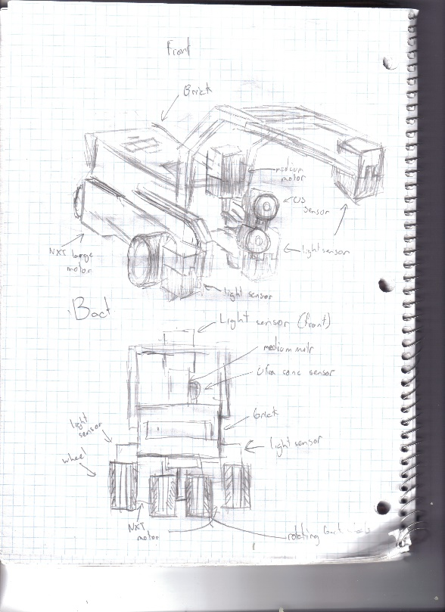

This design is very similar to “Preliminary Design #1.” The main difference is that this design uses the traditional wheels which were utilized from labs one to five. There’s also going to be a wheel at the back end supporting the robot (similar to the design of a plane). This wheel will be able to rotate whenever needed. Similar to Design #1, two light sensors will be used for the odometer correction and one light sensor will be placed about 11cm from the floor to detect the colours of the block. The two light sensors will allow for more accurate navigation results. Having the light sensors, a fixed distance from the blocks allow for more precise readings of the colours. One variable ultrasonic sensor will be implemented to detect blocks on all three sides of the robot. The ultrasonic sensor will be attached to a medium motor, allowing it to turn. The idea behind this robot is to have one half of the robot traveling on water while having the other half of the robot traveling on the bridge, mainly on the portion that is not affected by the bumps. This idea still needs to be confirmed by the professor.

EV3 Key Parts

* 3 light sensors (2 used for localization, 1 used for colour detection)
* 1 ultrasonic sensor
* 2 Large EV3 motors
* 1 Medium EV3 motor

**Advantages**

Advantages of this robot includes that the wheels are more accurate at navigation than the belt system. The robot itself is also a simple design without the complicated variable track method. Having the variable ultrasonic sensor allows the robot to detect objects on every side without the use of multiple ultrasonic sensor. Keeping the light sensor at a constant height to detect the block colours is a more efficient and accurate method. Finally, the use of two light sensors as a form of odometer correction will be more accurate than having a single light sensor on the back end of the robot.

**Disadvantages**

This idea is just a proposition as the group doesn’t know if this method will be accepted by the professor. Also, using the two light sensors for odometer correction is a method that the group never worked with before.

# 4 COMPARISONS OF dESIGNS

***Design #1***

During the first implementation of the treads, it was noticed that the treads were loose. Since the wheels were no spanning the entire length of the tread, they weren’t working to the best of their ability. The loose treads were evident when the robot tried to complete the square navigation. Visually, it was obvious the robot was not going in a straight line at all times.

During the second implementation of the treads, the front wheel was lifted lightly in order to slightly secure the treads. Having the front wheel lifted also helped with the traction as it made it easier for the robot to travel through the bumps. At the end of the day, the robot still had trouble in the navigation portion. The little errors compiled together at the end of the navigation.

***Design #2***

On the first design of the robot with regular wheels, a single marble was placed to carry the weight of the back end. Two wheels were placed on each motor to increase traction. While the robot seemed to complete the square navigation better than the treads, it had multiple issues crossing the bridge. The single marble at the back end changed the direction of the robot extensively. At the end, the robot couldn’t plow through the bumps on the bridge.

On the second design, two marbles were placed on the back. A marble was placed on each corner of the back end hoping the robot would be able to travel straight through the bumps better. While the robot traveled better than the first design, it still encountered complications when traveling though the bumps. The robot barely made it passed the bumps on the bridge. This concluded that the marbles were not a viable option to support the back end of the robot.

On the third design, marbles were completely excluded from the design. The marble was placed with a single wheel at the back end that was not controlled by a motor. During the testing on the bridge, the robot perfectly passed the bridge. It didn’t encounter any issues as it traveled relatively straight through the bumps and completed the bridge with ease. Navigation on this robot was not trialed as the back-end wheel was stabilized (was not a lazy wheel).

*Conclusion*

After taking everything into consideration, it was finalized that the regular wheels will be over the treads. Even though the treads traveled through the bumps more efficiently, the regular wheels were not far behind. Considering navigation will be a huge factor in completing the tasks, it is important to use the hardware that best perfects the navigation with ease.